Use-Case Realization Report
Delete Fap

Issue <1.0>
Revision History
Date | Issue | Description | Author
<02/08/09> | <1.0> | <Delete FAP> | <Karen Gao>

Table of Contents
1. Brief Description 4
2. Flow of Events 4
2.1 Standard Flow 4
2.2 Exceptions 4
3. Interaction Diagrams 4
3.1 Colloboration Diagram for Delete Fap 4
4. Participating Objects 4
5. Class Diagrams 5
5.1 Class Diagram for Delete Fap 5
6. Derived Requirements 5

Use-Case Realization Report
Delete Fap

Brief Description
This use case is used to delete the FAP.

Flow of Events

Standard Flow
This use case covers the events of deleting FAP, which is part of the maintenance FAP package. The standard flow of events is described as below:
- The Portal Administrator shall press the button to send out a command of “deleteButtonClicked” on the interface of MaintainFapPage.
- The operation checkFapToDelete of the FapController will check if there’s FAP selected.
- The FapController shall check whether any Fap is selected and show the selected Fap on the MaintainFapPage. Subsequently, it shall perform the getFap action and retrieve the FapList from the Fap object.
- The FapController shall then remove the FAP and display the new list on the MaintainFapPage.

Exceptions
- if there’s no FAP selected in checking of operation checkFapToDelete, a message will be sent to MaintainFapPage through the operation showNoFapSelectedMsg.

Interaction Diagrams

Colloboration Diagram for Delete Fap
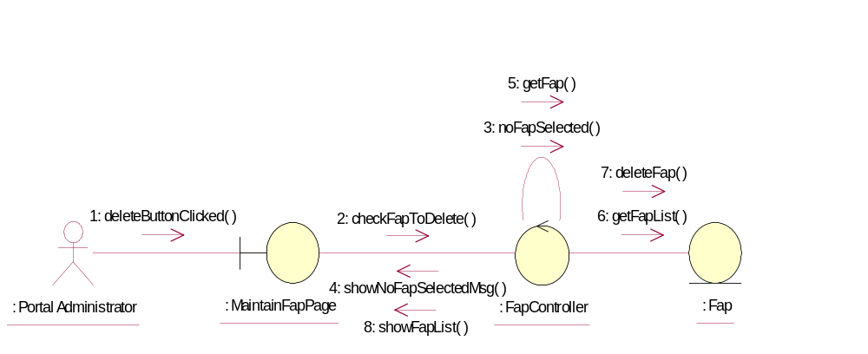

Participating Objects
: Fap
This Entity is Fap object

: FapController
This controller is to add, delete and update Fap

: MaintainFapPage
This is a page for adding, deleting, updating and displaying Fap

: Portal Administrator
This is the super user of the system.

Class Diagrams

Class Diagram for Delete Fap
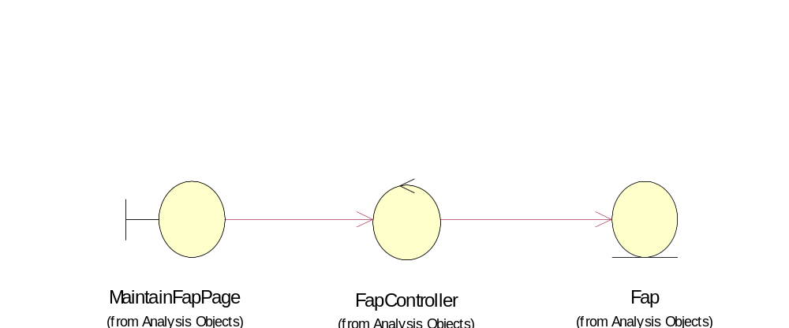

Derived Requirements
Only Portal Admin has rights to access this page.

